ULDD Export Guide
Fannie Mae established the Uniform Loan Delivery Dataset (ULDD), which is a common set of required data elements (MISMO Data Points) for loan delivery. An XML file containing the required ULDD data points is necessary for all MPF Xtra® loans, and it serves as the base data file for all other MPF® loans delivered via batch submission within eMPF®.
Participating Financial Institutions (PFIs) delivering loans under the MPF Xtra product, as well as using batch data file upload for MPF Traditional products and MPF Government MBS, will be required to submit the 3.0 ULDD XML file format.

*Note: DU MISMO 3.2 and 3.4 files are not accepted.
Guidance to export the Fannie Mae 3.0 ULDD file for select Loan Origination Systems (LOS) is provided below.

Wolters Kluwer:
Contact the Compliance Mortgage Application Team at 800-274-2711.
For Mortgage Support, select option 9, ext. 1123665. Have your WKCO customer number ready.

Inform WKCO that the 3.0 ULDD file is needed in an XML format for delivery to the MPF Program. This may require WKCO to do a quick install.

*Note: Some employees are more familiar with MPF requirements. If you are having issues, please contact us at 800-544-3452, ext. 2223.

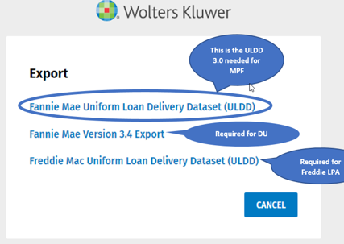

Encompass:
- Begin in the Pipeline View
- Right click; Select GSE Services
- Export ULDD to Fannie Mae (Selected Loans Only or All Loans on All Pages)
- Export and Save
- Upload to eMPF via transactions/batch submission

